**Module: CSE202 - Object Oriented Analysis & Design with Java**

**Assignment: Banking System (OOAD-Java Assignment 2025)**

**Student Name: Leano Carl Masogo**

**Student Registration Number: CSE24-154**

**Date Submitted: 19/09/2025**

**Part A**

**Banking System**

**Structural UML Modelling**

**2. System Use Case Diagram**

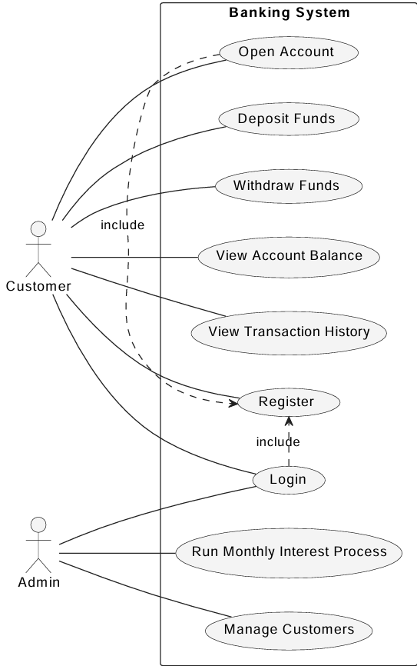

**2.2** **Class Diagram**

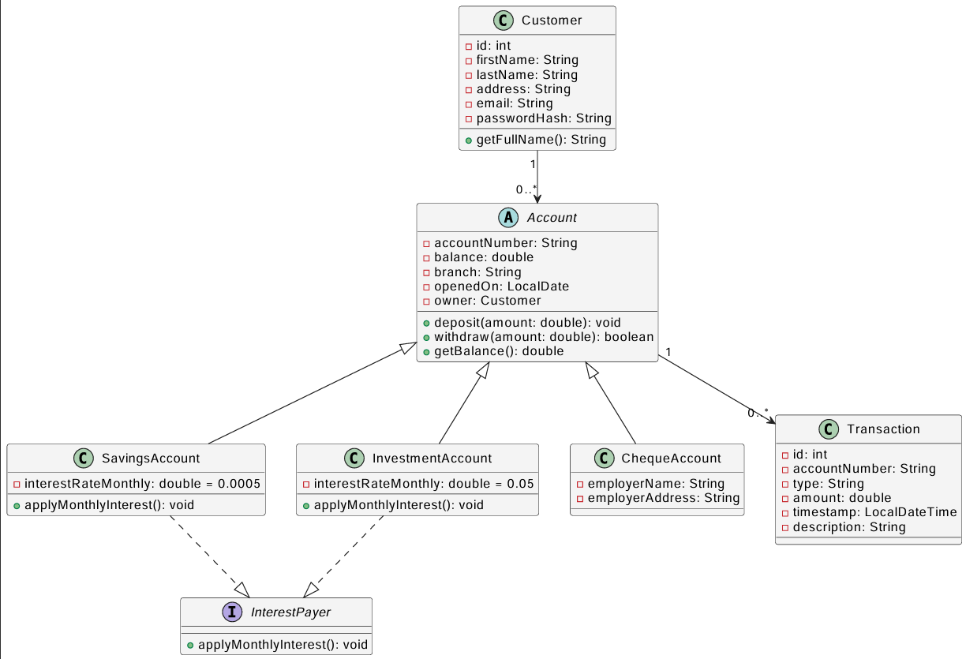

**3. Behavioural UML Modelling**

**3.1 Sequence Diagrams: Login**

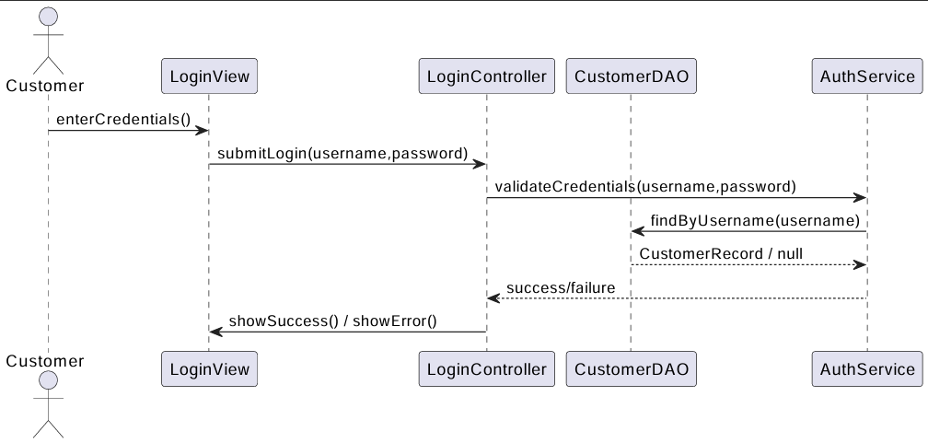

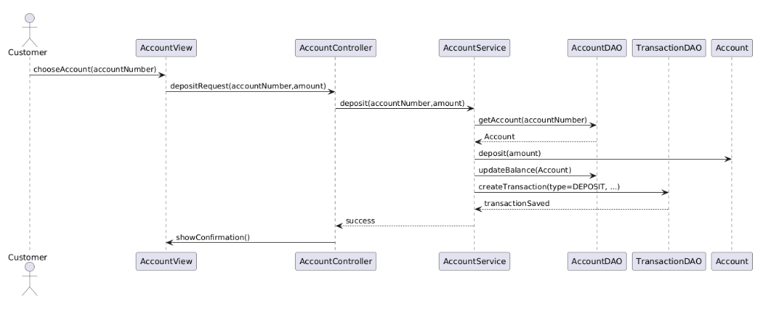**3.2 Sequence Diagram: Deposit**